## A.3 Individual Inspection 3

|  |  |  |  |  |
| --- | --- | --- | --- | --- |
| **Inspector:** Francesco Ratti | | | | |
| **Heuristic Type** | **Heuristic** | **Score** | **Comment** | **Reference** |
| Nielsen | Visibility of system status | 1 | Breadcrumb is visible on some pages, so the user should be able to know where he/she is. The problem here is that the breadcrumb is not effective: in any section, it shows just the current section name and an X.  X meaning isn’t so clear.  Moreover, when opening an article that takes us outside of the topic page, the breadcrumb disappears. In my opinion, the breadcrumb should be fixed to the top of the viewport, so the user has not to scroll to the top of the page. | Screenshot 3. 1  Screenshot 3. 2  Screenshot 3. 3  [Reply - Offering for Enterprise Architecture & SOA](https://www.reply.com/en/topics/architecture/)  [Reply - Smart Working and the Digital Workplace](https://www.reply.com/en/topics/digital-workplace/)  (almost any page) |



Screenshot 3. 1



Screenshot 3. 2

Screenshot 3. 3

|  |  |  |  |  |
| --- | --- | --- | --- | --- |
| **Heuristic Type** | **Heuristic** | **Score** | **Comment** | **Reference** |
| Nielsen | Match between system and the real world | 2 | Part of the website is in the destination language and part is still in English. | Screenshot 3. 4 |

Screenshot 3. 4

|  |  |  |  |  |
| --- | --- | --- | --- | --- |
| **Heuristic Type** | **Heuristic** | **Score** | **Comment** | **References** |
| Nielsen | User control and freedom | 5 | The user is freely able to navigate the site and leave the current page through the persistent header on top of the viewport. | Screenshot 3. 5  [Big Data Analytics: consulting, Applications, Tools | Reply](https://www.reply.com/en/topics/big-data-and-analytics/) |



Screenshot 3. 5

|  |  |  |  |  |
| --- | --- | --- | --- | --- |
| **Heuristic Type** | **Heuristic** | **Score** | **Comment** | **References** |
| Nielsen | Consistency and standards | 5 | Sharing icon coherent to standard ones (material design)  Lens icon to search which is a standard and arrow to indicate a dropdown menu when choosing the language.  Plus, minus to show more or less information and social network logos are consistent. | Screenshot 3. 6  Screenshot 3. 7  Screenshot 3. 8 |



Screenshot 3. 6



Screenshot 3. 7



Screenshot 3. 8

|  |  |  |  |  |
| --- | --- | --- | --- | --- |
| **Heuristic Type** | **Heuristic** | **Score** | **Comment** | **References** |
| Nielsen | Error prevention | 5 | Few simple items which allow navigation: upper bar menu voices and articles titles in the homepage topics: it is unambiguous that clicking on a title will lead the user to read the related article. | Screenshot 3. 5 |
| Nielsen | Recognition rather than recall | 2 | No suggestion when typing, this is a major drawback in my opinion since a user may don’t know precisely what to search on the website (he/she doesn’t know what kind of threads there are).  If the user commits a typo the system suggests the right search key, which is a great thing. | Screenshot 3. 9  Screenshot 3. 10  [Big Data Analytics: consulting, Applications, Tools | Reply](https://www.reply.com/en/topics/big-data-and-analytics/)  [Search (reply.com)](https://www.reply.com/en/search?k=machnine%20learning) |

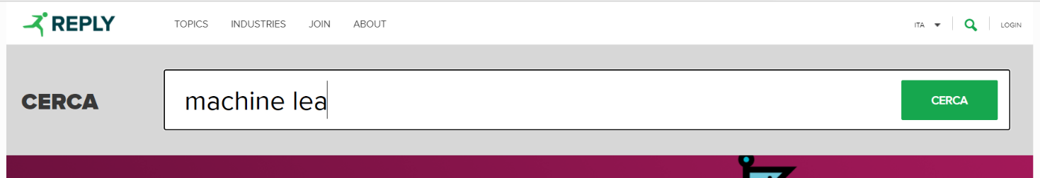

Screenshot 3. 9

Screenshot 3. 10

|  |  |  |  |  |
| --- | --- | --- | --- | --- |
| **Heuristic Type** | **Heuristic** | **Score** | **Comment** | **References** |
| Nielsen | Flexibility and efficiency of use | 2 | Navigation through topics in the top bar menu is confusing: topics are listed and no categorisation or grouping between them. *Screenshot 3.11*  No accelerators but maybe not needed | Screenshot 3. 11 |



Screenshot 3. 11

|  |  |  |  |  |
| --- | --- | --- | --- | --- |
| **Heuristic Type** | **Heuristic** | **Score** | **Comment** | **References** |
| Nielsen | Aesthetic and minimalist design | 2 | Too many items (articles) with long descriptions in a single page.  Everything is a bit “compacted” leading to a little information explosion.  Otherwise, good design. | Screenshot 3. 12  [AI & ML - Reply Offering](https://www.reply.com/en/topics/artificial-intelligence-and-machine-learning/)  (any section and homepage) |

Screenshot 3. 12

|  |  |  |  |  |
| --- | --- | --- | --- | --- |
| **Heuristic Type** | **Heuristic** | **Score** | **Comment** | **References** |
| Nielsen | Help users recognize, diagnose and recover from errors | 1 | The login error message is expressed in plain language but does not suggest a solution neither offers a way to go back, an “insulated” page which is completely different from the previous one appears leading to disorientation in the user. | Screenshot 3. 13  [Error Page](https://stscorp.reply.com/adfs/ls/auth/integrated/?wa=wsignin1.0&wtrealm=urn%3areplyeu%3awww&wctx=https%3a%2f%2fwww.reply.com%2fen%2ftopics%2fartificial-intelligence-and-machine-learning%2f_layouts%2f15%2fAuthenticate.aspx%3fSource%3d%252Fen%252Ftopics%252Fartificial%252Dintelligence%252Dand%252Dmachine%252Dlearning) |

Screenshot 3. 13

|  |  |  |  |  |
| --- | --- | --- | --- | --- |
| **Heuristic Type** | **Heuristic** | **Score** | **Comment** | **References** |
| Nielsen | Help and documentation | N/A | - | - |
| MILE Navigation | Interaction consistency | 5 | All topic and industries pages are structured according to the same layout and interaction principles.  All of them are articles preview container, which allow reading the full article when clicked. | - |
| MILE Navigation | Group navigation | 0 | An article in open in a new tab and no “navigation button” to next or previous article of the topic we come from is shown in the breadcrumb. Moreover, there is no way to go back to the previous page to navigate to the next article from the new tab. The breadcrumb offers a way to go to the homepage only. | Screenshot 3. 14  Screenshot 3. 15 |

Screenshot 3. 14



Screenshot 3. 15

|  |  |  |  |  |
| --- | --- | --- | --- | --- |
| **Heuristic Type** | **Heuristic** | **Score** | **Comment** | **References** |
| MILE Navigation | Structural Navigation | 4 | It is easy to navigate among the parts of a topic since everything is displayed on a single page. This leads to a bit of confusion. | - |
| MILE Navigation | Semantic Navigation | 0 | An article in open in a new tab and there is no way to navigate to related articles or articles of the same topic. Each article is alone. | - |
| MILE Navigation | Landmarks | 5 | All the landmarks are located in the header. Items of the header allow us to navigate to important parts of the website. | Screenshot 3. 16 |

Screenshot 3. 16

|  |  |  |  |  |
| --- | --- | --- | --- | --- |
| **Heuristic Type** | **Heuristic** | **Score** | **Comment** | **References** |
| MILE Content | Information overload | 0 | Every page contains too many articles and text leading to an information overload in my opinion. | Screenshot 3. 17 |

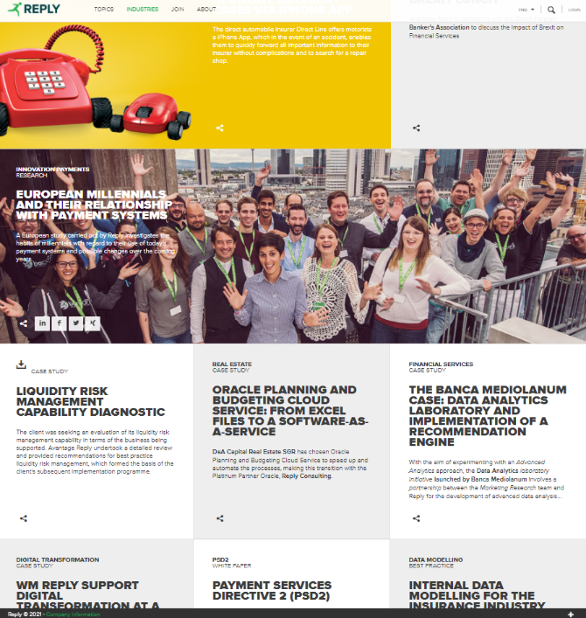

Screenshot 3. 17

|  |  |  |  |  |
| --- | --- | --- | --- | --- |
| **Heuristic Type** | **Heuristic** | **Score** | **Comment** | **References** |
| MILE Presentation | Text layout | 4 | Text is readable and the font size is generally right. Only the header top right elements are a bit small. | Screenshot 3. 18 |

Screenshot 3. 18

|  |  |  |  |  |
| --- | --- | --- | --- | --- |
| **Heuristic Type** | **Heuristic** | **Score** | **Comment** | **References** |
| MILE Presentation | Interaction placeholders-semiotics | 4 | Sharing icon coherent to standard ones (material design)  Lens icon to search which is a standard and arrow to indicate a dropdown menu when choosing the language. *Screenshot 3.6*  Plus (*screenshot 3.7*), minus to show more or less information and social network logos are consistent. *Screenshot 3.8*  The only negative part is that the items in the header are simply listed as labels with no semiotic care (no “intuitive” icons to make the most important ones easily recognisable). | Screenshot 3. 6  Screenshot 3. 7  Screenshot 3. 8 |
| MILE Presentation | Interaction placeholders-consistency | 3 | All the navigation placeholders are placed in the header, so labels positioning is correct, but the header is not fixed, so the user has to scroll to the top of the page every time.  Icons are consistent, as stated in “Interaction placeholders-semiotics” heuristic motivation.  All the topic landmarks are placed in the header in a clean label for each of them. | Screenshot 3. 19 |

Screenshot 3. 19

|  |  |  |  |  |
| --- | --- | --- | --- | --- |
| **Heuristic Type** | **Heuristic** | **Score** | **Comment** | **References** |
| MILE Presentation | Spatial allocation | 5 | Pages have a simple layout, consisting of a header for navigation, a body with related articles by category and a footer with “contact us” information. | - |
| MILE Presentation | Consistency of Page Structure | 5 | All topics and industries pages are structured according to the same layout principles, stated in the latter heuristic | - |